**The Role of Digital in Adopting a Customer-First Approach**

**Published 2 February 2022 - ID G00761333 - 13 min read**

**By Analyst(s): Financial Services Business Leader Research Team**

[Initiatives: Financial Services Business Leadership and Strategy; Financial Services](https://www.gartner.com/explore/initiatives/overview/44817) **Customer Experience, Talent and Delivery**

Digital is best-suited for enabling customers to manage day-to-day finances, but customers expect digital solutions even when handling complex and unexpected situations. Financial services leaders can use this research to bridge the gap between digital capabilities and customer expectations.

**Overview**

**Financial services leaders' digital investments are typically aimed at reducing cost to serve, thereby overlooking evolving customer needs and expectations. Consequently, customers who are increasingly using digital channels, often struggle to complete complex transactions on digital channels. With growing competition from new institutions (such as neobanks, fintechs and insurtechs), firms cannot risk customer relationships by offering suboptimal digital experiences.**

**Leaders need to think of their digital capabilities beyond self-service for day-to-day finances — they should offer personalized solutions and empower customers on their broader journeys. To create continuous engagement, firms need to tailor their products and solutions to meet customers' current and future needs.**

Key Findings



* **Digital investments are accelerating, but most of the digital efforts in the financial services industry have centered around helping customers manage their day-to-day finances through self-service capabilities.**
* **Customers' increased adoption of newer channels, such as chatbots and virtual assistants, during the pandemic signals a fundamental shift in how customers want to interact. As a result, they are more likely to reward firms when they can successfully use digital channels to plan for significant events and navigate unexpected situations. However, digital channels often fall short in such scenarios.**
* **To meet emerging customer expectations today, leaders will need to shift the digital channel strategy from enabling easier self-service for episodic transactions to helping customers achieve their broader life goals.**

Recommendations

**To support customers' better financial lives, financial services leaders should:**

* **Use data and analytics to create empowered customer journeys — build a holistic understanding of customers, and meet them where they are, while anticipating their needs.**
* **Use data-led, real-time customer insights to offer empathetic, personalized and contextual customer experience.**
* **Tailor products and services around the context of the customer to offer dynamic, context-based support by creating embedded financial relationships.**

The Current State of Digital Customer Experience

**The COVID-19 pandemic has accelerated the adoption of digital channels. Customers are no longer limiting themselves to the traditional digital channels (such as simple websites and mobile apps) and are migrating toward newer channels, such as chatbots and virtual assistants. In fact, 2.7 times more retail banking customers are using chatbots now compared with prepandemic, and 2.0 times more wealth management customers are using virtual assistants. 1**

**However, customers often find it difficult to complete interactions in digital channels, or are unable to find digital options for all their needs. This may be because digital channels are designed to improve efficiency, so they are best-suited to solve day-to-day financial transactions. Banks often struggle to deliver the desired outcomes when customers use digital channels for issues such as planning a significant event or handling an unexpected situation. In the example below, a customer wanted an option online to report potential fraud but could not find the help that he needed.**



**"I was looking around for a way to just say, 'Hey, can I dispute this?' And just push a few buttons and be done. But it wasn't that simple"**

— *Marcus (pseudonym) while using digital channels to report suspected fraud. Excerpts from interviews of North American retail banking customers, 2020 Gartner COVID-19 Customer Experience Survey.*

Value of Improving Digital Interactions

**Improving digital channel offerings to handle all kinds of issues and deliver higher customer engagement is a win-win for both customers and firms. Our research has found that 65% of customers who had high-quality interactions when handling unexpected situations through digital channels went on to take a positive action (such as advocating, using a service or making a purchase) for their providers (see Figure 1). Likewise, successful planning for a significant event through digital channels led to almost a 70% chance of customers taking a positive action. Currently, these two experiences in digital fall behind managing day-to-day finances, offering firms an opportunity to help customers and themselves by offering digital solutions to customers' complex life needs.**

**Figure 1: Digital Delivering Greater Value When Used to Solve Complex Life Needs**

Digital Delivering Greater Value When Used to Solve Complex Life Needs

Percentage of Customers Who Took a Positive Action After Receiving a High-Quality Experience Using Technology

80%

53%



Managing

Day-to-Day Finances (n =956)

69%



Planning for a Significant Event (n = 155)

65%



Handling an Unexpected Situation (n = 130)

Source: 2020 Gartner COVID-19 Customer Experience Survey

761333_C

**Gartner**

Evolution of Customer-Focused Digital Innovation

**Financial services firms can benefit from the growing demand for digital capabilities by serving customers in ways other than just helping them manage day-to-day finances. In addition to helping customers navigate complex situations, firms need to focus on delivering a high-quality digital experience that is empathetic, personalized and contextual. The value proposition needs to shift from delivering a faster and seamless experience to supporting the overall financial well-being of customers (see Figure 2).**

**Figure 2: Evolution of Customer-Focused Digital Innovation**

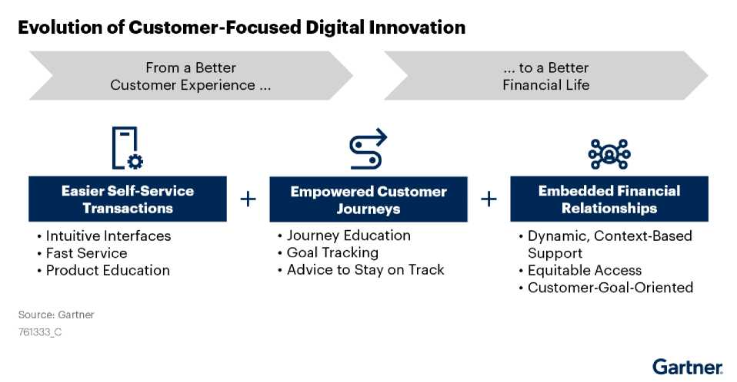

Roadmap to Supporting a Better Financial Life for Customers

**In addition to offering easier self-service transactions, firms need digital capabilities to understand customer context to empower customers to easily navigate and solve for a series of transactions that make up their entire journey. The next step in digital evolution is tailoring products and services around a customer's context by creating embedded financial relationships.**

**Creating Empowered Customer Journeys**

**The traditional approach of focusing on faster and easier self-service sees a customer interaction as a one-off or episodic situation and technology aims to make the transaction seamless. However, customers don't just live via one-off transactions. They are thinking of their broader life goals and how to accomplish them, which usually require solving a series of transactions that make up an entire customer journey.**

**Creating empowered customer journeys hinges on building a holistic understanding of the customer and delivering a tailored experience through digital channels. This can be achieved through the following:**

1. **Meeting customers where they are**
2. **Knowing their story**
3. **Anticipating their needs 1. Meet Customers Where They Are**

**Financial services leaders need to gather and analyze customer information to better understand where customers are in their journey, what goals are important to them and what they need to succeed in their journey. This will enable them to guide customers to the solution that they truly need.**

**Case in Point: Discovery-Oriented Digital Purchase Experience (Bank of America)**

**Bank of America ^ Bank of America's Better Money Habits 2 tool adopts a**

**"choose your own adventure" model that empowers customers by letting them decide what path they want to explore, based on their personal needs. Customers who know what they want can self-select the topic relevant to their needs and immediately get the required information. On the other hand, customers who are unsure and may need more guidance can complete a short, bite- size survey to help them prioritize their financial goals. The bank then guides further exploration based on a customer's self-selected jobs or outcomes that help them achieve their specific goals (see Figure 3).**

**The aim is to create an easy-to-navigate experience where the conversation is not about the bank's products, but is about empowering customers to understand and meet their financial need, and then guiding them to the right path. This provides a personalized customer journey without overwhelming the customer.**

**Ga**

**Figure 3: Bank of America's Better Money Habits**

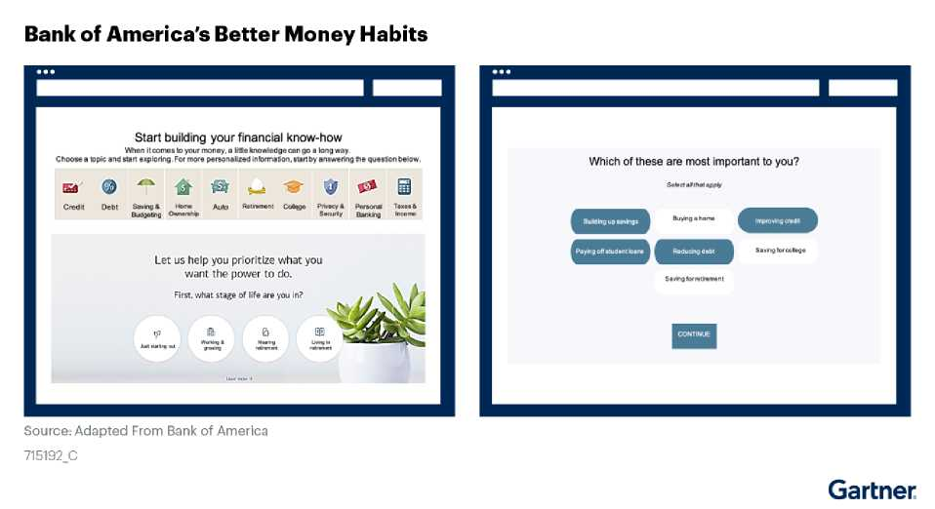

**2. Know the Customer's Story**

**Banks and insurance firms should use data and automation to build holistic profiles of their customers (using both financial and nonfinancial information) and scale that to impact the lives of all their customers. Leading firms are using digital channels and advanced automation tools to collect customer data and analyze it to provide tailored experiences. WeBank does this so well that it can extend credit to those who would typically be excluded from traditional financing, expanding into an untapped market, while successfully managing risk that other firms would not.**

**Case in Point: Automated SMB Credit Lending (WeBank)**

**WeBank was founded with the express purpose of engaging underserved consumers and small businesses, especially those who would not traditionally qualify for credit. One of the greatest challenges to serving these customers is that many do not have the history and documentation traditionally used to make credit decisions.**

***hleBank***

«ÄS!»

**To overcome this, WeBank launched an automated credit lending platform, mainly geared around small and midsize business (SMB) owners. The platform builds a holistic sense of business owners and their creditworthiness by looking at a wide array of nontypical metrics. For example, for small businesses, it looks at national ID bureaus, utility data, regulatory data and satellite-based imagery to see customers coming and going from their businesses. Its artificial intelligence (AI) can then build a more holistic view of the customer, using over 300 risk models and over 100,000 risk parameters that improve credit decisions over time. While WeBank does have access to data that might be restricted in other parts of the world, lessons related to how it analyzes data to understand customers will be critical for traditional firms moving into the future.**

**Since the platform was launched, WeBank has provided over 800,000 loans to small** [businesses, 60% of which had never received credit before. See Case Study:](https://www.gartner.com/document/code/749421?ref=authbody&refval=) **Automated, Technology-Driven SMB Credit Lending (WeBank).**

**3. Anticipate Customer Needs**

**Financial services leaders can also use data and analytics to recommend the next best action to customers, based on their context and unique needs. This can help protect customers and enable them to better manage their financial well-being by proactively addressing needs that customers may not even be aware of.**

**Case in Point: Customer Engagement Engine (Commonwealth Bank of Australia)**

**: ,r i r vji** ^ **Many organizations are actively expanding their channel**

of Australia '

**portfolios to meet customer demand and reduce cost to serve. However, the addition of new channels often makes it more difficult to deliver a seamless experience that guides customers and the organization to the most valuable interaction. Organizations often rely on the customer and employee judgment to determine the best channel to visit and action to take.**

**Commonwealth Bank of Australia (CBA) created a dynamic decisioning engine called the Customer Engagement Engine (CEE) to provide next best actions. The CEE is integrated into all its channels and uses analytics to anticipate customer needs, craft tailored actions for the customer and provide the best possible interaction at the right time, in the most appropriate channel.**

**The CEE now recommends over 2,000 types of next best conversations tailored to individual customers' needs and context, creating a connected and relevant experience for the customer regardless of channel. For example, a customer calls about credit card balance, and the CEE recognizes that this customer could be served better through a higher-yield savings account. It will prompt the frontline agent to ask if the customer will be interested in the savings account. If the customer says, "Yes," the agent can help the customer with the application on the same call.**

**As a result, CBA's Net Promoter Score in its mobile app is 12 points higher than those of its competitors. The company also saw a 12% increase in customers opening a higher-yield savings account as a result of a CEE-suggested interaction. As part of CBA's "benefit finder" interaction, customers have claimed over $150 million in** [benefits. See How Commonwealth Bank of Australia Uses Data to Improve the CX: A](https://www.gartner.com/document/code/755088?ref=authbody&refval=) **Customer Service and Support Perspective.**

**Meeting customers where they are, knowing their story and anticipating their needs are key to empowering customer journeys and helping customers live better financial lives. However, simply empowering customer journeys will not be enough to remain competitive, as fintechs and leading financial services firms continue to raise the bar for customer expectations in the coming years. Financial services leaders should prepare for the future by investing in digital capabilities and partnerships that can enable embedded financial relationships.**

**Creating Embedded Financial Relationships**

**Most financial services leaders are transitioning from simplifying individual customer transactions to empowering broader customer journeys. In these contexts, a firm's products and services on offer are static, but customers' needs and expectations are constantly changing, especially as they move from one journey to the next. Hence, firms should be able to adapt to the changing customer context and deliver tailored experiences and support. They can achieve this by embedding financial services in the collection of journeys that make up the customer's life.**

**Embedded financial relationships integrate real-time customer data (describing the "real life" situations that customers are living through) and third-party relationships to deliver a more personalized, tailored product for the customer. While this concept is still new to financial services, leaders can learn from other industries that are already making progress against this emerging vision.**

**| Case in Point: Customer-Focused Digital Innovation (Land O'Lakes)**

**For over a decade, Land O'Lakes — a U.S.-based farmer- owned cooperative — has been offering digital solutions to help clients (farmers and agriculture retailers) select the right feed, seeds and fertilizers. But soon, it realized that the clients' world was not just about having the right seeds or fertilizers. Clients were trying to navigate a complex web of decisions to maximize production, such as how to optimize the yield from the fields, or when and whom to sell to maximize profits.**



**LAND O'LAKES, inc**



**To meet the evolving, unpredictable client needs more effectively, the company connected an ecosystem of clients and multiple digital solution providers via digital platforms and online marketplaces. The important players in the ecosystem are clients (farmers, agriculture retailers, and food and consumer goods companies), co-founders (Land O'Lakes in partnership with Microsoft) and agtech companies (such as Bayer and John Deere), connected via digital platforms.**

**The ecosystem helps clients and providers create mutually beneficial, scalable relationships that accelerate the digitalization of agriculture. Through this digital platform, Land O'Lakes now looks at the broader complexities and uncertainties that farmers face through the entire cycle and enables tailored solutions. The farmers provide data to feed the analytics engines, and in return, they are rewarded with insights that help them run their businesses better.**

**This ecosystem boosted customer-centric product innovation, drove efficiencies in the company's supply chain, and opened the door to new digital business models. It has helped more than 3,000 farmers, resulting in a 19% increase in retention rates and $2.3** [billion in top-line sales in 2020 alone. See Case Study: Innovation Ecosystems for](https://www.gartner.com/document/code/750719?ref=authbody&refval=) **Digital Business Transformation (Land O'Lakes).**

**In financial services, the Land O'Lakes example would look like firms analyzing data from across their networks of customers to help small businesses manage their cash flows better, or access insights about their end customers. Similarly, financial services leaders in retail banking or wealth management could provide insights to help customers better manage their personal finances, based on keys to success and common pitfalls observed among their entire customer base. Insurance firms could use this to provide guidance on how customers can lower their premiums by changing behaviors, or offer more- personalized pricing as customers change personas over the course of their lives.**

**Conclusion**



**Digital capabilities are integral to the growth story of banks and insurance companies, but are not evolving fast enough to keep pace with changing customer needs and expectations. In today's age of accelerated digital adoption, customer empowerment and threat from fintechs, a company's value proposition can no longer be about only enabling fast and easy self-service. Banks and insurance providers need to move toward offering an experience that also empowers customers to solve for their journeys and sets the foundation for a future of embedded financial relationships.**

**Recommended by the Authors**

[Top Trends in Financial Services Product Reinvention for 2021](https://www.gartner.com/document/code/752828?ref=authbody&refval=)

**About This Research**

**This research is based on interviews with financial services leaders, interviews with retail banking customers and the 2020 Gartner COVID-19 Customer Experience Survey. The survey was conducted via an online panel from September 2020 through October 2020, collecting responses from 5,502 retail banking respondents. Quotas and weights were applied for age, gender, region and income at the country level, so that the sample mirrors the distribution of the retail banking population.**

**The results of this survey are representative of the respondent base and not the "global" retail banking population as a whole. The surveys were developed collaboratively by a team of Gartner researchers and quantitative analysts and were reviewed, tested and administered by Gartner's Research, Data, Analytics and Tools team.**

**The organizations profiled in this research are provided for illustrative purposes only, and do not constitute an exhaustive list of examples in this field nor an endorsement by Gartner of the organizations or their offerings.**

**Evidence**

1. **2020 Gartner COVID-19 Customer Experience Survey.**
2. [Better Money Habits](https://bettermoneyhabits.bankofamerica.com/en)**, Bank of America.**

© 2022 Gartner, Inc. and/or its affiliates. All rights reserved. Gartner is a registered trademark of Gartner, Inc. and its affiliates. This publication may not be reproduced or distributed in any form without Gartner's prior written permission. It consists of the opinions of Gartner's research organization, which should not be construed as statements of fact. While the information contained in this publication has been obtained from sources believed to be reliable, Gartner disclaims all warranties as to the accuracy, completeness or adequacy of such information. Although Gartner research may address legal and financial issues, Gartner does not provide legal or investment advice and its research should not be construed or used as such. Your access and use of this publication are governed by [Gartner's Usage Policy](https://www.gartner.com/technology/about/policies/usage_policy.jsp). Gartner prides itself on its reputation for independence and objectivity. Its research is produced independently by its research organization without input or influence from any third party. For further information, see "[Guiding Principles on Independence and Objectivity](https://www.gartner.com/technology/about/ombudsman/omb_guide2.jsp)."

